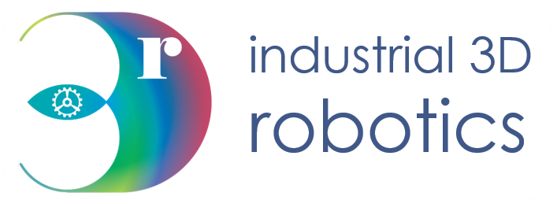

Stereo Vision Toolkit

User Guide

Contact Details

|  |  |
| --- | --- |
| Correspondence Address: | I3D Robotics Ltd  Pipers Business Centre  220 Vale Road  Tonbridge  Kent  TN9 1SP  UK |
| Email: | info@i3drobotics.com |
| Phone: | +44 (0)1732 373020 (09:00 – 17:00 UK) |
| Fax: | +44 (0)1732 373001 |

About this Manual

Who is this for?

This manual is intended for a user with I3D Robotics Stereo Camera. It will help the operator understand how to get the most out of this new product using the Stereo Vision Toolkit

What is in it?

This manual provides the operator with instructions on how to install and use this software package.

|  |  |
| --- | --- |
| Installation | Instructions on install the software package |
| How do I use it? | How to use the stereo vision toolkit |
| FAQ | Frequency ask questions. Will help will assist with commonly known problems. |

Disclaimer

THE INFORMATION CONTAINED HEREIN IS PROVIDED "AS IS" WITHOUT WARRANTY, CONDITION OR REPRESENTATION OF ANY KIND, EITHER EXPRESS, IMPLIED, STATUTORY OR OTHERWISE, INCLUDING BUT NOT LIMITED TO, ANY WARRANTY OF MERCHANTABILITY, NON-INFRINGEMENT OR FITNESS FOR A PARTICULAR PURPOSE.

IN NO EVENT SHALL I3D ROBOTICS BE LIABLE FOR ANY LOSS OR DAMAGE, WHETHER DIRECT, INDIRECT, SPECIAL, INCIDENTAL, CONSEQUENTIAL OR OTHERWISE HOWSOEVER CAUSED WHETHER ARISING IN CONTRACT TORT OR OTHERWISE, ARISING OUT OF OR IN CONNECTION WITH THE USE OF THE INFORMATION PROVIDED HEREIN.

**COPYRIGHT AND PROTECTIVE NOTICES:**

The copyright in this document and the associated drawings are the property of I3D ROBOTICS Ltd. and all rights are reserved. This document and the associated drawings are issued on condition that they are not copied, reprinted or reproduced, nor their contents disclosed. The publication of information in this documentation does not imply freedom from any patent or proprietary right of I3D Robotics or any third party.

**TRADEMARKS**

I3D ROBOTICS and the I3D ROBOTICS logo are trademarks of I3D ROBOTICS Ltd. All other marks are property of their respective owners.

Contents

1 Introduction 6

1.1 System requirements 7

1.2 Mechanical and Electrical Information 7

1.3 Certification 8

2 Stereo specification 8

3 Installation 9

3.1 Unpacking and handling 9

3.2 What should I have? 10

4 Operation 10

4.1 Using the Stereo Vision Toolkit 10

4.2 Installation 10

4.3 Acquiring images 10

4.4 Matching images 12

4.5 Viewing point clouds 15

4.6 Using the projector 16

4.7 Calibration 17

5 Using external libraries 20

5.1 OpenCV 20

5.2 Using ROS 21

# Introduction

|  |  |
| --- | --- |
| Software compatibility |  |
| Windows 7+ (64bit)  cross-platform support coming soon | |

## System requirements

The table below outlines the minimal requirements of the connected computer running the user software.

|  |  |
| --- | --- |
|  |  |
| Processor | Intel i3/5/7 or similar |
| RAM | 4GB |
| Hard disk space | 500MB |
| Graphics card | CUDA compatible card recommended, but not required. |
| Connectivity | USB3 |

# Installation

## What should I have?

* Stereo camera system
* USB3 Cable / GigE ethnet cable depending on camera system
* USB key containing software, documentation and factory calibration

# Operation

## Using the Stereo Vision Toolkit

We provide an open source GUI tool to experiment with your camera. The tool can be used to acquire images, perform stereo image matching and view live 3D point clouds. For most applications, we would expect that customers will integrate the camera using their own software (e.g. using the OpenCV library), but our toolkit is designed for rapid application prototyping.

The software installer is provided on a USB stick, or may be downloaded from our Github repository (<https://github.com/i3drobotics/stereo-vision-toolkit>) either a windows installer from the releases section, or as source which you can compile yourself. If you wish to compile from source, we provide library dependencies built using Visual Studio 2017 x64 in the repository.

## Installation

An installer for the toolkit software is on the provided USB key. You can find the latest release on the repository (link above).

You will have been provided with a factory stereo calibration file on a USB stick with your camera. Place this in your installation folder, in the ‘params’ folder as the software will look there by default. Alternatively, you can specify the location in-software and the path will be saved in the application’s configuration file.

Notes:

* You may need administrator privileges to copy these files if you installed the software to a protected folder (e.g. Program Files).
* The toolkit will store its configuration in the Windows registry at: Computer\HKEY_CURRENT_USER\Software\I3Dr\Stereo Vision Toolkit

## Connecting to camera

First, make sure your stereo camera is plugged in. If using USB preferably USB3 to achieve the best framerate. If using GigE then either connected the machine running the software directly or into the same network.

Open the software, you will be presented with an interface which is mostly disabled until a camera is connected. The below image shows this view, on the left a list of cameras is shown. This will display all the camera currently available which will refresh every 5 seconds. You can manually refresh this list by pressing the ‘refresh list’ button.

Open the software, you will be presented with the stream from the two cameras. The acquisition tab is shown below:

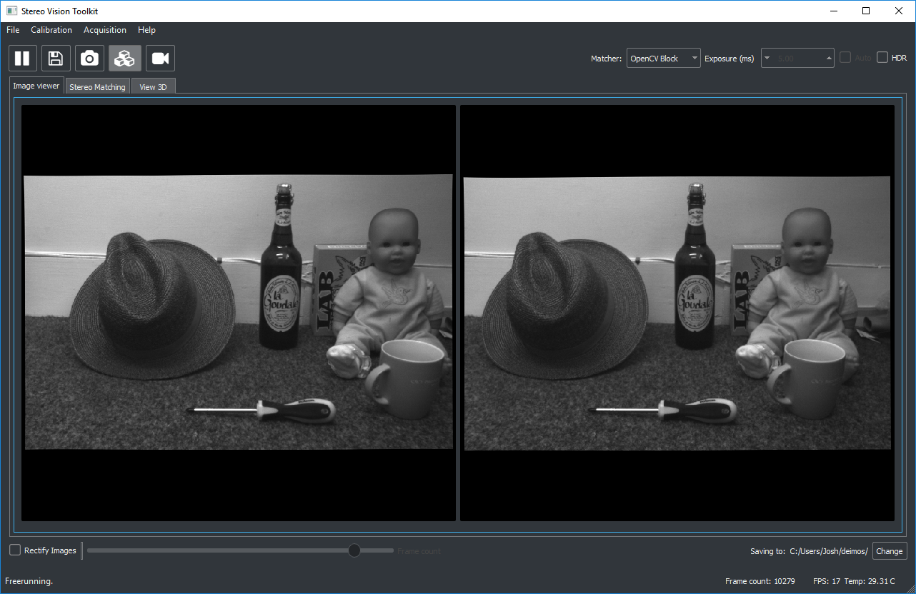

The different features of the toolkit are arranged by tab. The first tab shows the stream from each camera. You can check the frame rate in the status bar at the bottom, as well as the camera’s reported temperature from an onboard sensor. This is calculated using an assumed ambient temperature of 20 C. Also, in the status bar, you can see the frame count[1] and the current output directory.

The toolbar provides you with the following options:

|  |  |  |
| --- | --- | --- |
| Command | Button | Description |
| Play/Pause |  | Start or stop the camera image stream |
| Save |  | Save the current frame to a user-specified folder |
| Snapshot |  | Grab a single frame and then pause |
| Enable matching |  | Toggle stereo matching |
| Record video |  | Start or stop recording a stereo video |

At the top right, you can specify which matcher to use (currently OpenCV Block or OpenCV SGBM), the camera’s exposure time in ms (or auto-expose) and whether to toggle HDR mode. HDR mode is useful for suppressing highlights in the scene, and does not affect the maximum framerate, especially in conjunction with auto-expose mode.

## Matching images

Once you have loaded in the correct calibration files for your camera, you can enable image rectification and start matching. Alternatively, if you are loading a video that’s already been rectified, then you can enable matching regardless.

The matching window has three sections: the view from the left camera, the disparity map and the parameters for the selected stereo matcher. Parameter changes will update in real time, allowing you to experiment to find out what works best for your scene.

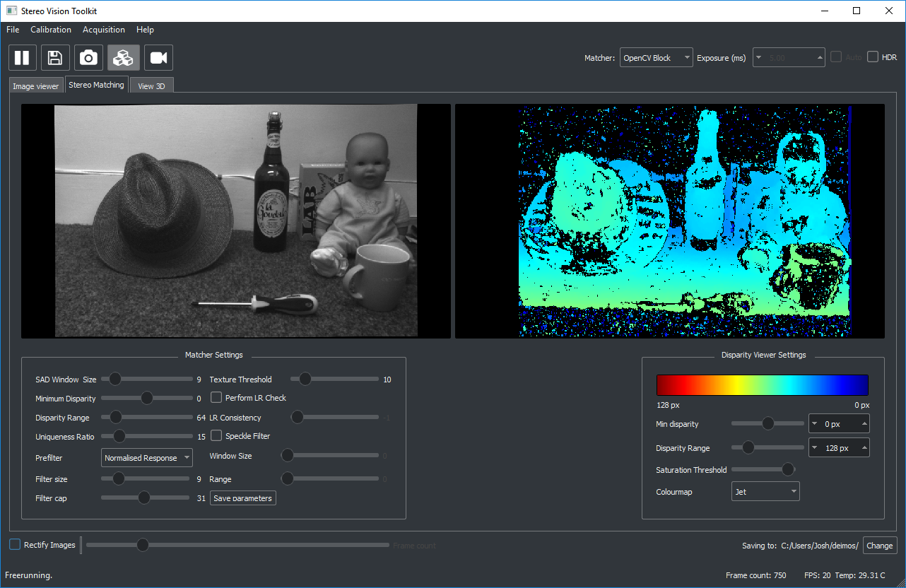

Two matchers are provided currently, both from OpenCV. The first is a block matcher which local area matching[2]. This is a fast and simple method which can give good results, particularly if using the projector. However, it can struggle with repetitive objects. The second algorithm is the OpenCV implementation of Semi-Global Matching which is a more sophisticated algorithm and runs quite a lot slower than block matching.

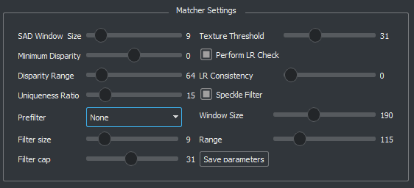

There are several common parameters (further description may be found in OpenCV’s documentation [here](https://docs.opencv.org/3.0-beta/modules/calib3d/doc/camera_calibration_and_3d_reconstruction.html#createstereosgbm))

**Window size** – sets the size of the comparison region. Bigger values will produce denser disparity maps at the expense of fine detail and edge sharpness.

**Minimum disparity** – set the minimum disparity to search from.

**Disparity range** – set the number of disparities to search over.

**Uniqueness ratio** – sets how confident the algorithm must be before a match is allowed. Set this to a high value to improve robustness at the expense of disparity map density.

**LR Check** – enable an approximate left-right consistency check, which can reduce noise in the disparity map.

**Texture threshold** – minimum image texture to allow matching, can avoid spurious matches in featureless regions.

**Speckle filter** – a post-processing step to remove small outliers in the disparity map. Generally setting both range and window size to be high works well.

Block matching also has the option to pre-filter the image which can improve noise in the disparity map.

When you are happy with the parameters you have chosen, you can opt to save them as defaults for the next time you run the application.

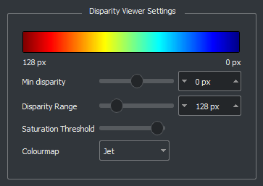

On the right, you can control the visualisation settings for the disparity map including the disparity minimum and range (the same as for the matcher), the choice of colourmap and a filter to filter pixels that are brighter than a certain amount. Saturation filtering can be useful if very bright lights are observed by the cameras.

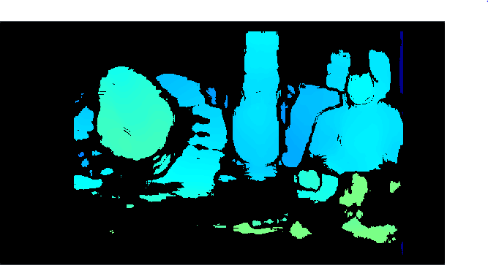 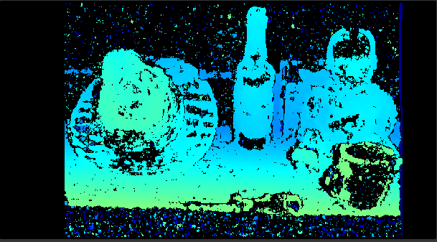

Figure 1 Left: disparity map with a SAD window size of 30 px, Right: disparity map with a SAD window size of 9 px

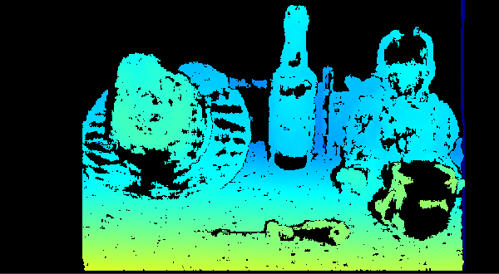 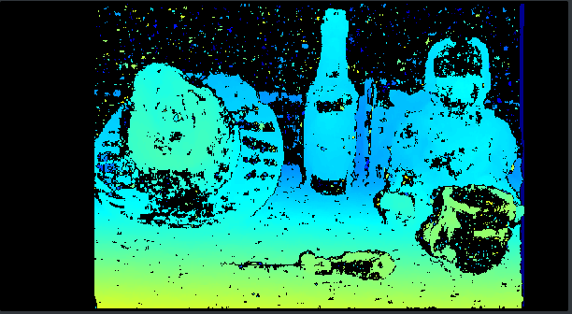

Figure 2 Left: Speckle filtering enabled, Right: no speckle filtering

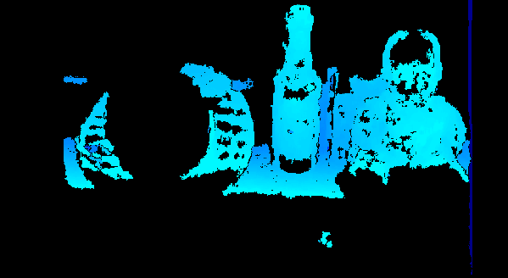 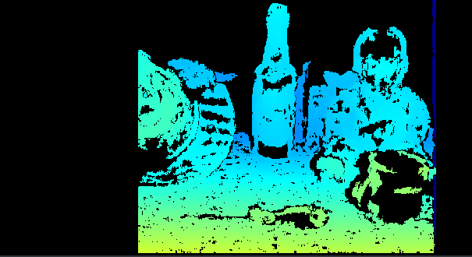Figure 3 Left: A small disparity range of 32 px does not match the whole image. Right: A higher range of 192 px matches more of the image closer to the camera, but also reduces the region of the image that can be matched.

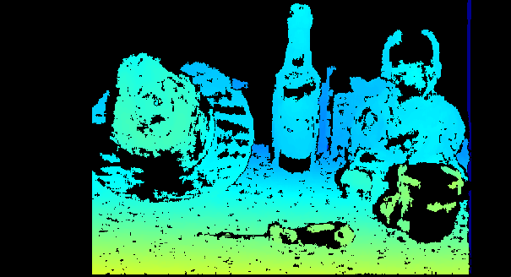 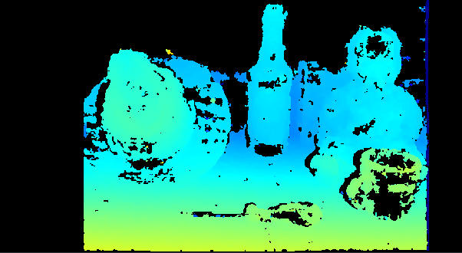

Figure 4 Left: OpenCV Block Matcher Right: OpenCV SGB Matcher

For most applications you will probably need to tweak the matcher settings to get the best reconstruction for a specific scene, and depending on the desired trade-off between point cloud sparsity and robustness.

## Viewing point clouds

If the camera is properly calibrated, you can switch to the third tab to see the disparity map projected into 3D space. The point cloud is displayed with the image intensity overlaid on top of it.

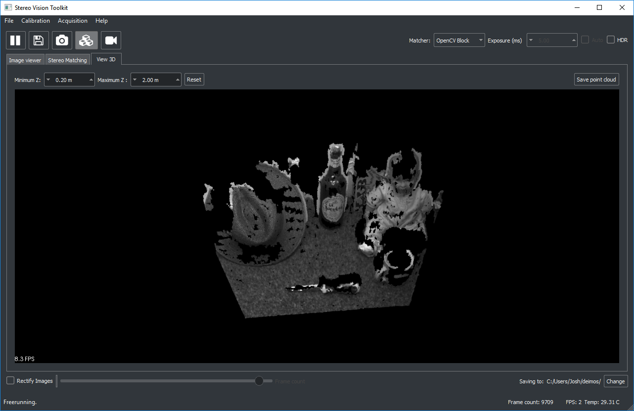

You can zoom with the mouse wheel and rotate with the left mouse button. Holding shift and clicking pans the scene.

Set the min/max Z distance to limit the range of points shown.

You can save the current point cloud as a PLY file for viewing in other software, such as the freely available Meshlab or CloudCompare.

Click the reset button to refresh the view. Occasionally the point cloud will not appear immediately and you may need to shift the view slightly to re-render it.

## Using the projector

The Deimos unit contains an infrared laser pattern projector for illuminating featureless indoor targets (like walls). **Although the laser is Class 1 – eye safe, users should practise good laser safety by avoiding staring into the beam or holding the unit close to faces while the projector is on. Never hold the projector close to your eye while turned on.**

The projector has a range of a few metres, depending on the ambient illumination and surface type. Challenging surfaces include matt black objects (e.g. computer monitors), translucent and transparent objects, and shiny (specular) objects such as mirrors or polished metal.

The projector is enabled by using the slide switch on the rear of the system.

The effectiveness of the projector is shown below. Note that the block matcher was used with identical settings for each image. The projector enables reconstruction of the wall as well as improved surface reconstruction of objects in the scene.

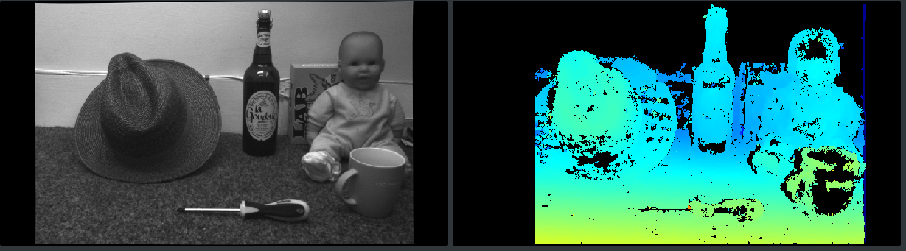

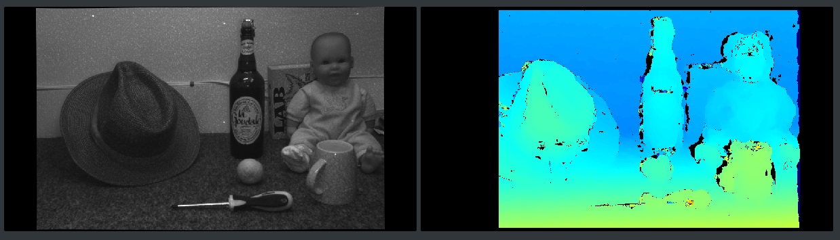

Figure 5 Top: without pattern projector, Bottom: with pattern projector.

Note that as the projector is visible to the camera sensors, the texture pattern will be visible in the resulting images which may or may not be suitable for your application. For example, this would not be suitable for combining image intensity from multiple stereo pairs as the scene illumination will change with the camera position. However, applications where only geometry is considered should not be affected.

## Calibration

Calibration is required to reconstruct 3D images using Deimos, or any stereo camera. The purpose of camera calibration is to obtain the intrinsic parameters of each camera, which include the focal length of the lens, the intersection between the lens optical axis and the sensor plane (camera centre) and the characteristics of the lens’ distortion. This is sufficient to ‘undistort’ a single camera – a simple way to think about it is that straight lines in the world become straight in the undistorted image. For stereo systems, an extrinsic calibration is also needed which describes the relative positions of the cameras with respect to each other. Combined with the intrinsic calibrations for each camera, a rectification transform is calculated which warps the raw images prior to stereo matching.

Your camera is provided with a (tested) factory calibration which should remain stable in transit. However, you may wish to perform your own calibration and sooner or later you will probably need to. If you adjust the focus of the lenses yourself, or if for some reason you find that the images are failing to match (even with the projector on) then you can try a re-calibration.

First, print off a calibration target: <https://docs.opencv.org/2.4/_downloads/pattern.png>

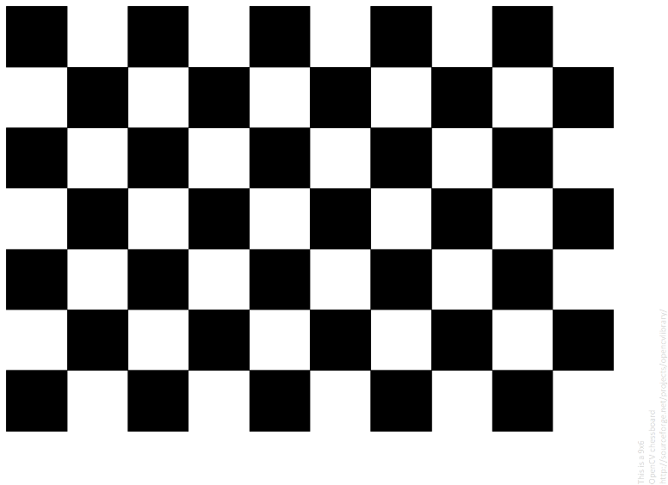

Corner

Figure 6 A standard ‘chessboard’ calibration target. We refer to the calibration points as corners, the points where the square vertices meet. The red box highlights the ‘active’ area of the pattern, which should be visible in all images.

You should print with as high a resolution as your printer will allow. An A4 target is the minimum recommended size, you may have better results with an A3 or even A2 target. Ensure that the aspect ratio of the print is fixed, if you have rectangles rather than squares, the calibration will be poor. If using a poster printer, be aware that glossy finishes usually suffer from specular reflections from room lighting.

Fix the printed calibration to a stiff board or surface, such as a sheet of wood or aluminium. The surface should be as close to planar as possible. Avoid taping the edges of the target, as over time paper tends to warp and the target will no longer be flat. A better solution is to glue the target to the board.

Measure the width of one of the calibration squares as accurately as you can – ideally using the software you printed the target with, if possible (print 1:1). The calibration algorithm attempts to locate ‘corners’ – points where the corners of the squares meet (see Figure above).

Next, specify a convenient save directory and capture some stereo image pairs of the target in different positions and orientations. It is important that you include images of the pattern tilted, and at various points and scales in the field of view. If your images are too similar, your calibration will be poor. This is important to accurately determine the distortion parameters for the lenses.

A typical selection of orientations might be:

1. Face on, close to camera
2. Face on, far from camera
3. Left image edge, tilted at various angles
4. Right image edge, tilted at various angles
5. Top image edge, tilted at various angles
6. Bottom image edge, tilted at various angles

Some example images (left only) are shown below:

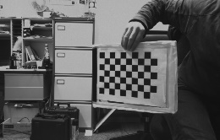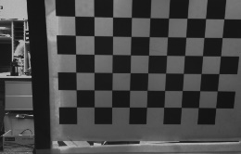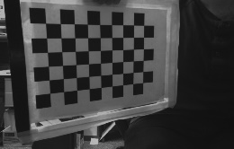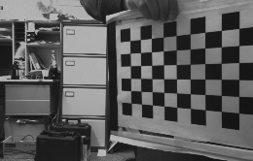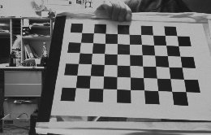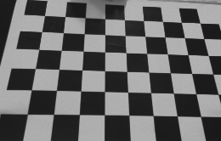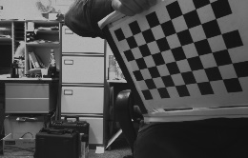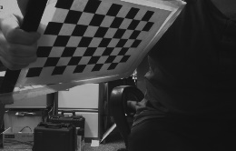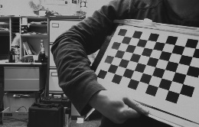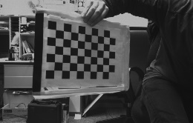

Figure 7 An example set of calibration images, using an A4 target printed on a board.

Capturing 10 calibration pairs should be enough for many cases. Make sure the pattern is fully visible in both cameras. Once you’re done, open the calibrate from images tool:

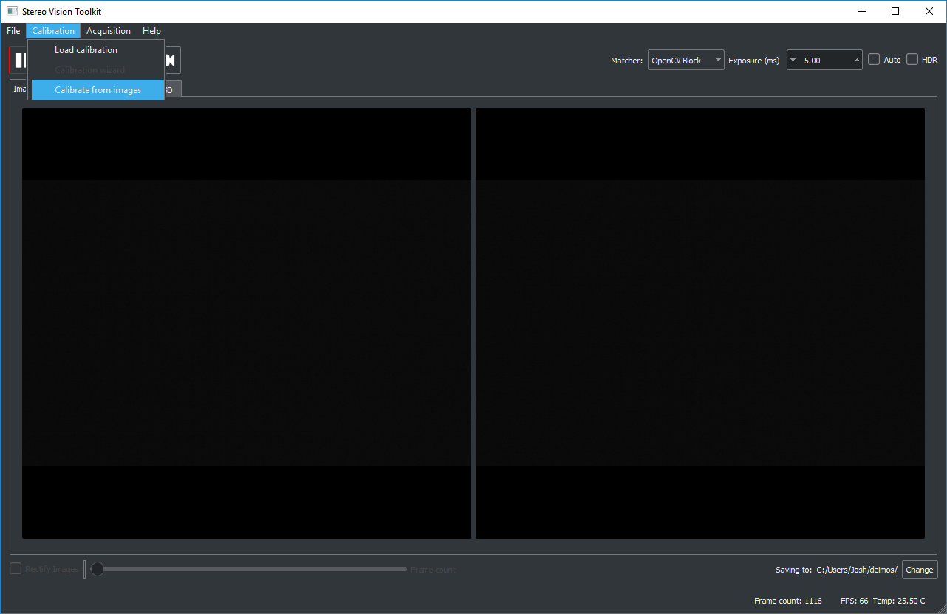

Follow the instructions in the dialog window, providing the location of the left and right calibration images. The default image file mask should work. Make sure you set the correct pattern size (the image above is an 6 x 9 ) and the correct square size in millimetres.

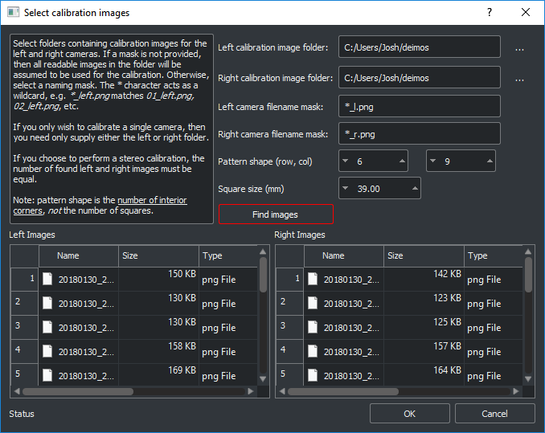 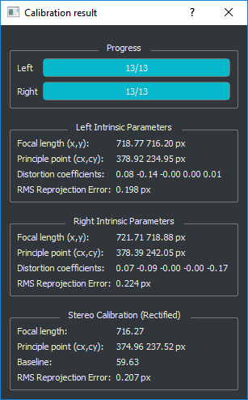

Figure 8 Left: the calibrate-from-images tool. Right: the calibration result using the calibration images in Figure 6. Note the good stereo RMS reprojection error of 0.2 px.

Click “Find images” and ensure that the images you just captured appear in the table. There should be an equal number of left and right images.

Click OK to perform the calibration. The calibration will take a few seconds to complete, depending on how many images you used. Once done, you will see a dialog with the result. A good calibration error (RMS reprojection error) is less than 0.25 px.

Finally, load your calibration files by selecting the folder that the calibration was saved to (currently the application directory). You can move the files somewhere else if you wish to, e.g. for backup or if using multiple Deimos cameras. Check the calibration works by seeing if you get sensible stereo matching results.

# Using external libraries

## OpenCV

You can use the Deimos camera in OpenCV (C++/Python). Simply load the camera as a VideoCapture object and set the resolution to 752 x 480. Frames are returned as a 3-channel colour images. The last two channels correspond to the left and right images respectively.

from matplotlib.pyplot import *

import cv2

cap = cv2.VideoCapture(0)

cap.set(cv2.CAP_PROP_FRAME_HEIGHT, 480)

cap.set(cv2.CAP_PROP_FRAME_WIDTH, 752)

image = cap.read()[1]

image = np.flipud(image)

imshow(image)

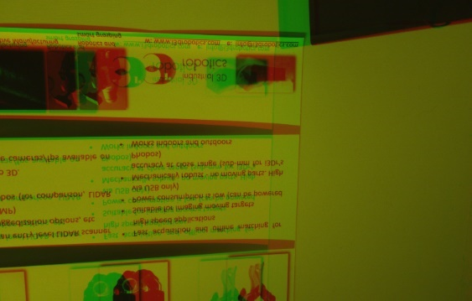

f = figure()

subplot(121)

imshow(image[:,:,1], cmap='gray')

subplot(122)

imshow(image[:,:,2], cmap='gray')

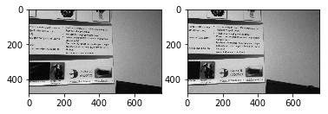

Note that manual exposure control is not possible directly using OpenCV. This is controlled using a HID interface to the camera. Example code for controlling the camera in C++ can be found in the [stereo vision toolkit](https://github.com/i3drobotics/stereo-vision-toolkit/blob/master/src/stereocameradeimos.cpp).

## Using ROS

A compatible ROS node for the camera may be found [here](https://github.com/dilipkumar25/see3cam). This node also provides access to the camera’s onboard IMU as a topic and allows you to control the camera exposure.

Since the camera enumerates as a UVC compatible device, you should be able to use Deimos in most imaging libraries with generic capture interfaces.

# Troubleshooting

## Framerate is slower than expected

Check that you are not performing any graphics-heavy processing on the same machine. The stereo vision toolkit automatically performs rectification using your GPU (if available). Similarly, if you are doing any heavy computation work, this may slow down stereo matching.

## I only get 30fps, not 60fps

This is typically because the camera is operating in USB2 mode. Please check that you are using a USB3 port, and that it has sufficient bandwidth. Alternatively try using a different USB cable.

## Image matching is poor

It’s possible you need to recalibrate the system. First, try to image a target that is amenable to matching, with lots of features. A blank wall with the projector turned on is a good option. If you still do not get good match results, then perform a recalibration and try again. Check that the rectification appears to be sensible – straight lines in the world should be straight in the images.

## Projector doesn’t work

Check that the switch on the back of the device is turned to the on position and check that your USB port is capable of delivering enough current. The projection wavelength is near-infrared, so you won’t be able to see it with your eyes, but it should be visible to the camera where it will appear overlaid on the image.

If your projector still does not turn on, please contact I3Dr.

## USB connector is not secure

This is a common problem USB3 Micro-B connectors over time, particularly if they are removed and re-inserted frequently. We provide the Deimos system with tapped holes, usable with standard USB3 vision cables (with screw locks). You may find that another USB3 cable provides better latching.

## Can I use Deimos on a tripod?

Deimos features two M4 holes on its base, however tripod screws are typically ¼-20 thread. Please contact I3Dr if you need a tripod adaptor.

## I’m having problems with the software

Please visit the [Github repository](https://github.com/i3drobotics/stereo-vision-toolkit/blob/master/src/stereocameradeimos.cpp) and post an issue (preferred), or contact us for assistance. Remember

The camera does not need additional drivers.

## I’m getting high calibration errors (> 0.3 px)

* Make sure that you are in a brightly lit area, and lower the exposure time, to prevent motion blur
* Use HDR mode
* Capture more calibration images, making sure that the board is present at different distances and with a large variety of orientations relative to the sensor
* Check that the pattern size you provided is correct

## I can’t see any 3D output

Sometimes you may need to move the view slightly (using your mouse) to re-render the point cloud. You need a valid calibration to project to 3D, as the camera projection matrix must be known.

## Where can I find out more about stereo imaging?

The canonical reference textbook for stereo imaging geometry is Hartley and Zisserman, *Multiple View Geometry in Computer Vision* (OUP), however there is little information on matching. Unfortunately there are few good books on stereo, in terms of a good algorithm comparison, so it’s usually better to look at the relevant papers.

You can look at Scharstein and Szeliski’s stereo taxonomy paper (<https://doi.org/10.1109/SMBV.2001.988771>) or the OpenCV calib3d documentation (<https://docs.opencv.org/2.4/modules/calib3d/doc/calib3d.html>). For information on the calibration routine used, take a look at Zhang’s paper (<https://www.microsoft.com/en-us/research/publication/a-flexible-new-technique-for-camera-calibration/>).

You can also look at the Middlebury and KITTI stereo benchmarks for a more comprehensive algorithm comparison, though note that the test data has existed for a while and there is likely to be some bias towards matchers which work well on that data. For example, the top KITTI performer is a deep neural net trained on driving imagery, so it’s not clear how well it would transfer to other domains.

1. This can be helpful as an indicator that the camera is still capturing images.
2. It compares a small patch in the left image and attempts to locate its match in the right image using correlation.